**Lab 2**

## Roll no. 20L-1027

## Name: Fatima Azfar

Question no. 1:

1. **A.B’+A’**

|  |  |  |  |  |
| --- | --- | --- | --- | --- |
| **A** | **B** | **A’** | **B’** | **A.B’+A’** |
| 0 | 0 | 1 | 1 | **1** |
| 0 | 1 | 1 | 0 | **1** |
| 1 | 0 | 0 | 1 | **1** |
| 1 | 1 | 0 | 0 | **0** |

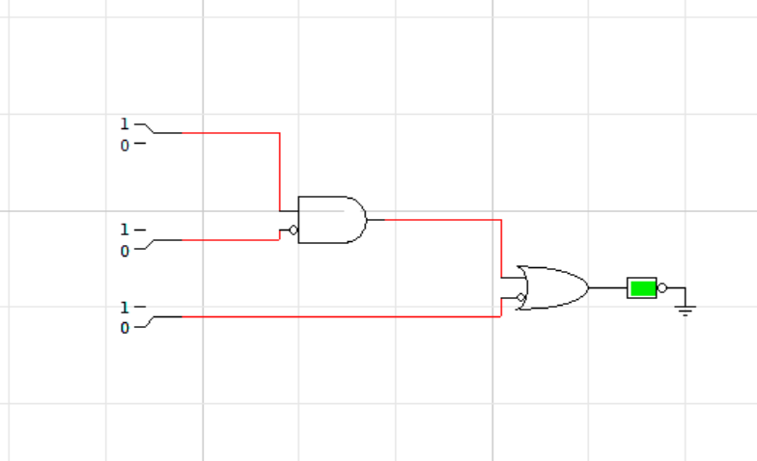

1. **A.B + A’.B’**

|  |  |  |  |
| --- | --- | --- | --- |
| **A** | **AB** | **B** | **A.B + A’.B’** |
| 0 | 0 | 0 | **1** |
| 0 | 0 | 1 | **1** |
| 0 | 1 | 0 | **1** |
| 0 | 1 | 1 | **1** |
| 1 | 0 | 0 | **1** |
| 1 | 0 | 1 | **0** |
| 1 | 1 | 0 | **1** |
| 1 | 1 | 1 | **1** |

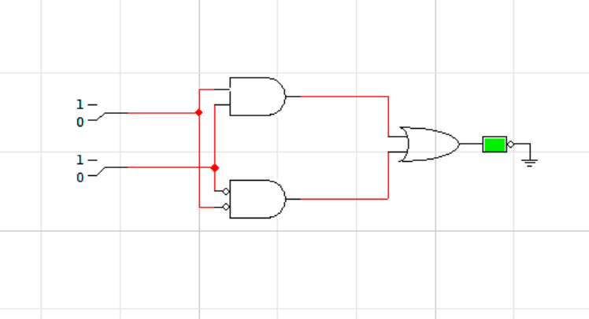

1. **ABC + (A+B+C)**

|  |  |  |  |  |
| --- | --- | --- | --- | --- |
| **A** | **ABC** | **B** | **C** | **ABC + (A+B+C)** |
| 0 | 0 | 0 | 0 | **0** |
| 0 | 0 | 0 | 1 | **1** |
| 0 | 0 | 1 | 0 | **1** |
| 0 | 0 | 1 | 1 | **1** |
| 0 | 1 | 0 | 0 | **1** |
| 0 | 1 | 0 | 1 | **0** |
| 0 | 1 | 1 | 0 | **1** |
| 0 | 1 | 1 | 1 | **1** |
| 1 | 0 | 0 | 0 | **1** |
| 1 | 0 | 0 | 1 | **1** |
| 1 | 0 | 1 | 0 | **1** |
| 1 | 0 | 1 | 1 | **1** |
| 1 | 1 | 0 | 0 | **1** |
| 1 | 1 | 0 | 1 | **1** |
| 1 | 1 | 1 | 0 | **1** |
| 1 | 1 | 1 | 1 | **1** |

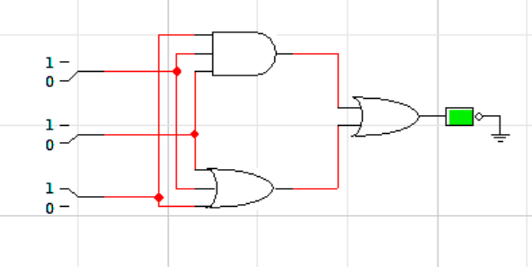

Question no.2:

1. **A.B’+A’**



1. **A.B+A’.B’**



1. **(A.B.C)+(A+B+C) **
2. **(A.B.C).(A+B+C)**

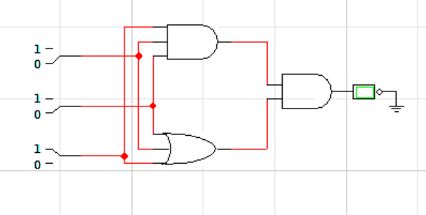

1. **BC’D’+A’B’CD’+ABD’**

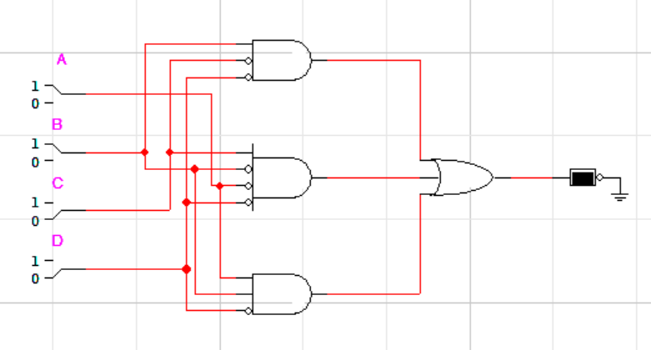

Question no. 3:

1. **X + XY = X**

LHS:

= X + XY

= X(1 + Y)

= X(1)

= X

= RHS

Hence Proved.

1. **X(X’ + Y) = XY**

LHS:

= X(X’ + Y)

= XX’ + XY

= (0) + XY

= XY

= RHS

Hence Proved.

1. **X + X’Y = X + Y**

LHS:

= X + X’Y

= X.1 + X’Y

= X(1 + Y) + X’Y

= X + XY + X’Y

= X + Y(X + X’)

=X+Y(1)

= X + Y

= RHS

Hence Proved.

Question no. 4:

**F1=XYZ + X’Y + XYZ’**

**CIRCUIT:**

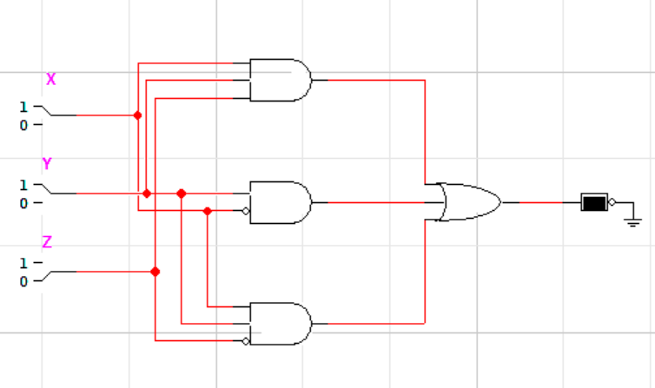

**TRUTH TABLE:**

|  |  |  |  |  |  |  |  |  |
| --- | --- | --- | --- | --- | --- | --- | --- | --- |
| **X** | **Y** | **Z** | **X’** | **Z’** | **XYZ** | **XYZ’** | **X’Y** | **F1** |
| 0 | 0 | 0 | 1 | 1 | 0 | 0 | 0 | **0** |
| 0 | 0 | 1 | 1 | 0 | 0 | 0 | 0 | **0** |
| 0 | 1 | 0 | 1 | 1 | 0 | 0 | 1 | **1** |
| 0 | 1 | 1 | 1 | 0 | 0 | 0 | 0 | **1** |
| 1 | 0 | 0 | 0 | 1 | 0 | 0 | 0 | **0** |
| 1 | 0 | 1 | 0 | 0 | 0 | 0 | 0 | **0** |
| 1 | 1 | 0 | 0 | 1 | 0 | 1 | 0 | **0** |
| 1 | 1 | 1 | 0 | 0 | 1 | 0 | 0 | **0** |

Question no. 5:

1. **F2 = (X+Y).(X+Z’).(Y’+Z’)**

Compliment:

F2 = (X’.Y’)+(X’.Z)+(Y.Z)

1. **F3 = (X’Y’)+(Y’Z’)+(X’Z’)**

Compliment:

F3 = (X+Y).(Y+Z).(X+Z)

Question no. 6:

1. **F4 = (XY + YZ + ZX)**

Dual:

F4 = (X+Y).(Y+Z).(Z+X)

This Boolean expression is self-dual because it has equal number of min and max term and it does not contain any mutually exclusive terms.